7-Day Survival Trip

PLEASE GET IN TOUCH WITH US info@fieldskills.com FOR AN ITINERARY AND/OR PROPOSAL

Thank you!

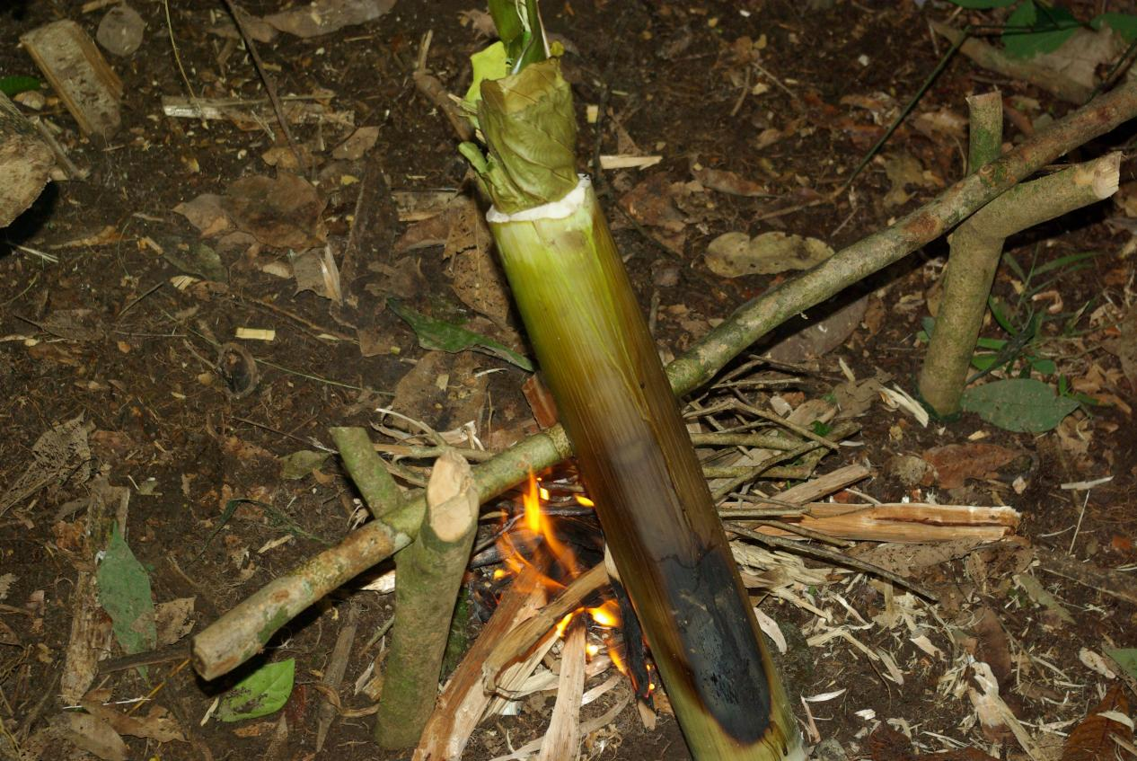
Survival cooking

FIELDSKILLS ADVENTURES SDN BHD
FIELDSKILLS TRAINING SERVICES
S-2-11, BLK C, 2ND FLOOR, CITY MALL
JALAN LINTAS, 88300 KOTA KINABALU,
SABAH, BORNEO
MALAYSIA
Tel : +6 088 416330

